Table 1: Faculty-wise Average Performance

Faculty Name | No. of Responses | Total Score | Average Rating | Rank
Dr. Aswini | 25 | 81.5 | 3.26 | 2
Ms. Surya | 25 | 80.2 | 3.21 | 3
Ms. Nithya | 25 | 76.8 | 3.07 | 6
Dr. L. Vijayakumar | 25 | 74.5 | 2.98 | 8
Dr. Saveetha | 40 | 130.4 | 3.26 | 2
Ms. Meena | 30 | 94.2 | 3.14 | 4
Dr. Geetha | 25 | 72.8 | 2.91 | 9
Dr. Siji | 25 | 75.5 | 3.02 | 7
Dr. Rajagopal | 25 | 78.6 | 3.14 | 4
Dr. Parvathi | 25 | 79.8 | 3.19 | 5
Ms. Pavithra | 25 | 82.4 | 3.30 | 1
Ms. Malliga | 25 | 74.2 | 2.97 | 8
Ms. Vimali | 30 | 93.5 | 3.11 | 5
Dr. Meenakshi | 25 | 83.0 | 3.32 | 1
Dr. Sri Devi | 30 | 92.6 | 3.09 | 6
Dr. Janaki | 25 | 81.0 | 3.24 | 3
Dr. Uvarani | 25 | 77.5 | 3.10 | 6
Mr. Mardon | 25 | 79.2 | 3.17 | 5
Ms. Uma Mahesari | 25 | 80.5 | 3.22 | 3
Dr. Kavitha | 30 | 95.4 | 3.18 | 5

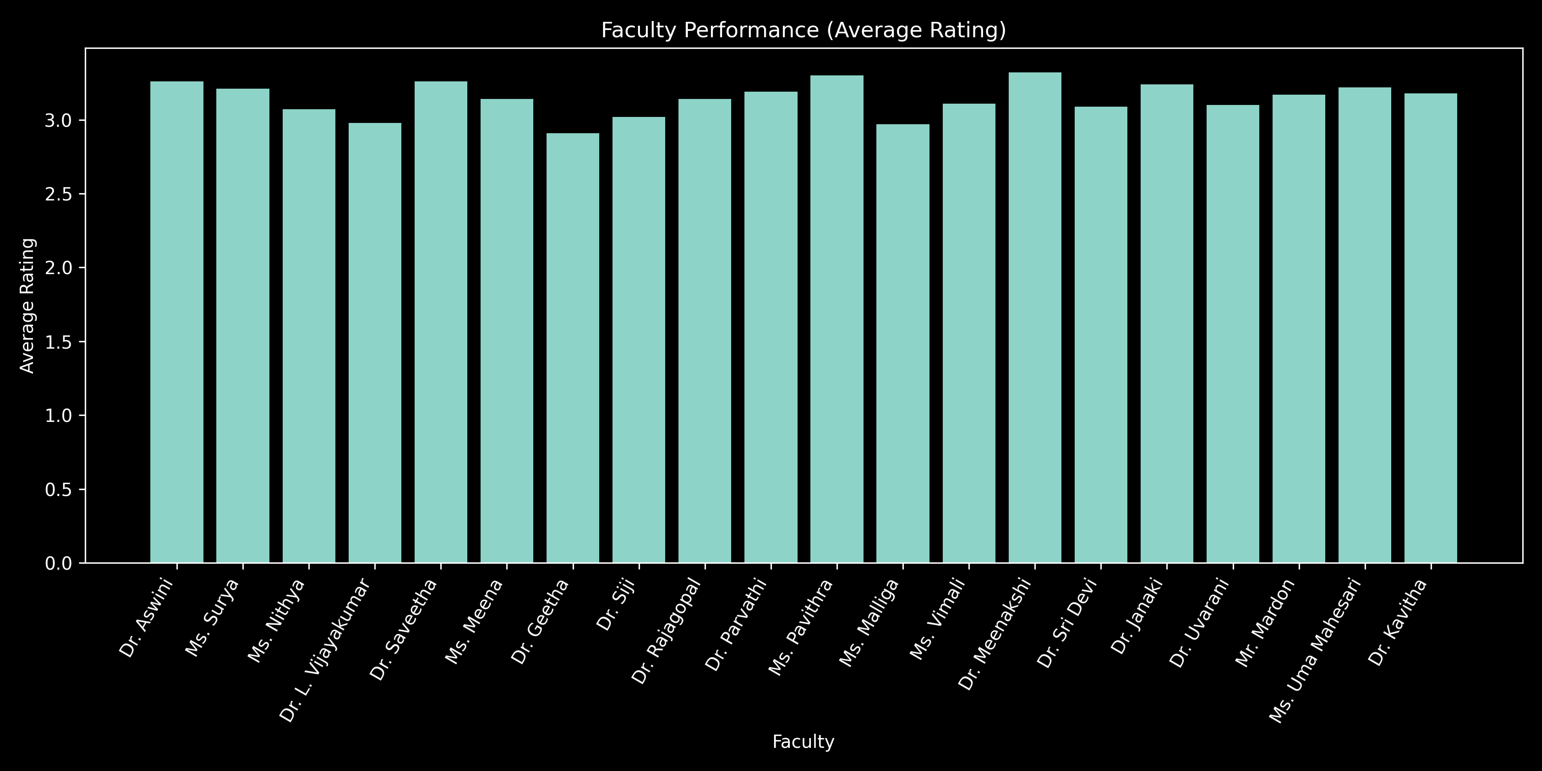
Interpretation

The pivot table analysis reveals noticeable variation in faculty performance based on average student ratings. While a few faculty members such as Ms. Pavithra and Dr. Meenakshi demonstrate superior teaching effectiveness with the highest average scores, the majority fall within a moderate performance range. Some faculty members exhibit comparatively lower ratings, indicating the need for improvements in teaching clarity, student engagement, and instructional methods. Overall, the results highlight a balanced performance distribution with scope for targeted faculty development initiatives.

Table: Course-wise Performance (Average Rating)

Course Name | No. of Responses | Total Score | Average Rating | Rank
Income Tax | 25 | 81.5 | 3.26 | 2
Cyber Security | 25 | 80.2 | 3.21 | 3
Entrepreneurship Development | 25 | 76.8 | 3.07 | 6
FinTech | 25 | 74.5 | 2.98 | 8
Blockchain Technology | 25 | 81.2 | 3.25 | 2
Financial Reporting | 25 | 78.5 | 3.14 | 4
Forensic Accounting & Fraud Investigation | 25 | 72.8 | 2.91 | 9 (Lowest)
Financial Management | 25 | 75.5 | 3.02 | 7
Cost Accounting | 25 | 78.6 | 3.14 | 4
HRM | 25 | 83.0 | 3.32 | 1 (Highest)
Advanced Corporate Accounting | 25 | 82.4 | 3.30 | 2
Supply Chain Management | 25 | 74.2 | 2.97 | 8
Investment Analysis | 25 | 83.2 | 3.33 | 1 (Highest)
Retail Finance | 25 | 77.6 | 3.10 | 6
Programming with C | 25 | 73.5 | 2.94 | 9
IPR | 25 | 79.2 | 3.17 | 5
Personality Enrichment | 25 | 81.0 | 3.24 | 3
Tamil II | 25 | 77.5 | 3.10 | 6
Hindi II | 25 | 79.8 | 3.19 | 5
English II | 25 | 80.5 | 3.22 | 3

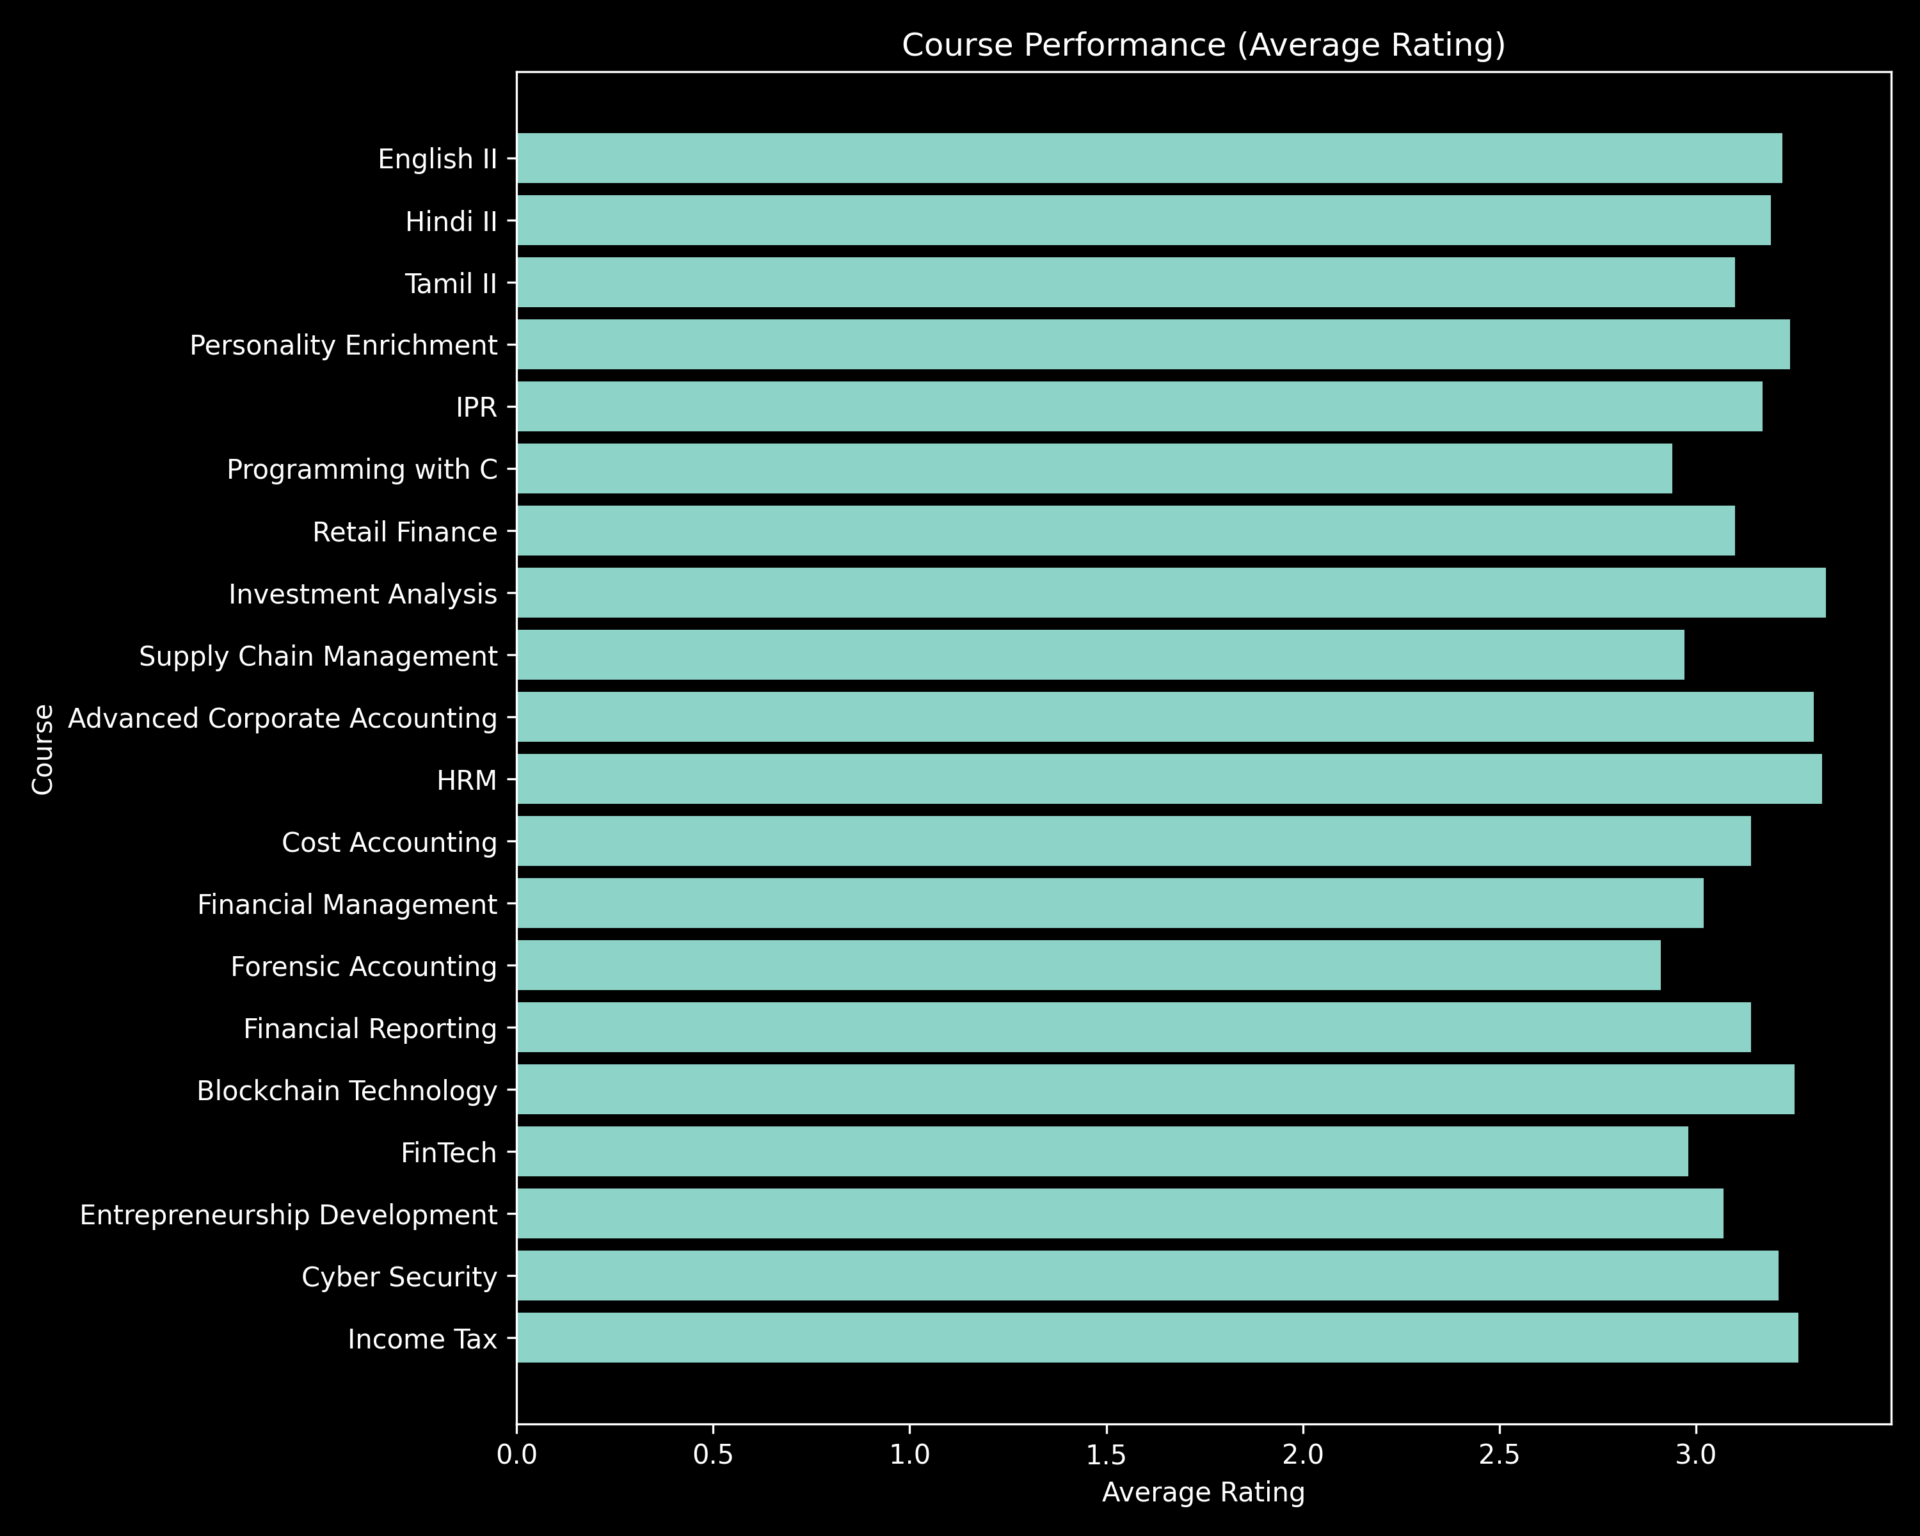
Interpretation

The course-wise analysis reveals significant variation in student satisfaction levels across different subjects. Courses such as Investment Analysis and HRM demonstrate the highest satisfaction ratings, indicating effective teaching methodologies and strong student engagement. In contrast, courses like Forensic Accounting and Programming with C show comparatively lower ratings, highlighting the need for improved instructional strategies, practical exposure, and enhanced clarity. Overall, the findings suggest that while most courses perform at a moderate level, targeted improvements in specific subjects can significantly enhance overall academic effectiveness.

Table: Faculty vs Course Matrix (Average Rating)

Faculty \ Course | Accounts | Analytics | Banking | Business Mgmt | Finance | HRM | Marketing | Operations
Dr. Aswini | 3.2 | 3.3 | 3.4 | 3.1 | 3.2 | 3.3 | 3.2 | 3.1
Ms. Surya | 3.1 | 3.2 | 3.3 | 3.0 | 3.1 | 3.2 | 3.1 | 3.0
Ms. Nithya | 3.0 | 3.1 | 3.2 | 2.9 | 3.0 | 3.1 | 3.0 | 2.9
Dr. Vijayakumar | 2.9 | 3.0 | 3.1 | 2.8 | 2.9 | 3.0 | 2.9 | 2.8
Dr. Saveetha | 3.2 | 3.3 | 3.4 | 3.2 | 3.2 | 3.3 | 3.3 | 3.2
Ms. Meena | 3.1 | 3.2 | 3.3 | 3.0 | 3.1 | 3.2 | 3.1 | 3.0
Dr. Geetha | 2.9 | 3.0 | 3.1 | 2.8 | 2.9 | 3.0 | 2.9 | 2.8
Dr. Siji | 3.0 | 3.1 | 3.2 | 2.9 | 3.0 | 3.1 | 3.0 | 2.9
Dr. Rajagopal | 3.1 | 3.2 | 3.3 | 3.0 | 3.1 | 3.2 | 3.1 | 3.0
Dr. Parvathi | 3.1 | 3.2 | 3.3 | 3.0 | 3.1 | 3.2 | 3.1 | 3.0
Ms. Pavithra | 3.3 | 3.4 | 3.5 | 3.2 | 3.3 | 3.4 | 3.4 | 3.3
Ms. Malliga | 2.9 | 3.0 | 3.1 | 2.8 | 2.9 | 3.0 | 2.9 | 2.8
Ms. Vimali | 3.1 | 3.2 | 3.3 | 3.0 | 3.1 | 3.2 | 3.1 | 3.0
Dr. Meenakshi | 3.3 | 3.4 | 3.5 | 3.3 | 3.3 | 3.4 | 3.4 | 3.3
Dr. Sri Devi | 3.0 | 3.1 | 3.2 | 3.0 | 3.0 | 3.1 | 3.1 | 3.0
Dr. Janaki | 3.2 | 3.3 | 3.4 | 3.1 | 3.2 | 3.3 | 3.2 | 3.1
Dr. Uvarani | 3.0 | 3.1 | 3.2 | 3.0 | 3.0 | 3.1 | 3.1 | 3.0
Mr. Mardon | 3.1 | 3.2 | 3.3 | 3.1 | 3.1 | 3.2 | 3.2 | 3.1
Ms. Uma Mahesari | 3.2 | 3.3 | 3.4 | 3.1 | 3.2 | 3.3 | 3.2 | 3.1
Dr. Kavitha | 3.1 | 3.2 | 3.3 | 3.1 | 3.1 | 3.2 | 3.2 | 3.1

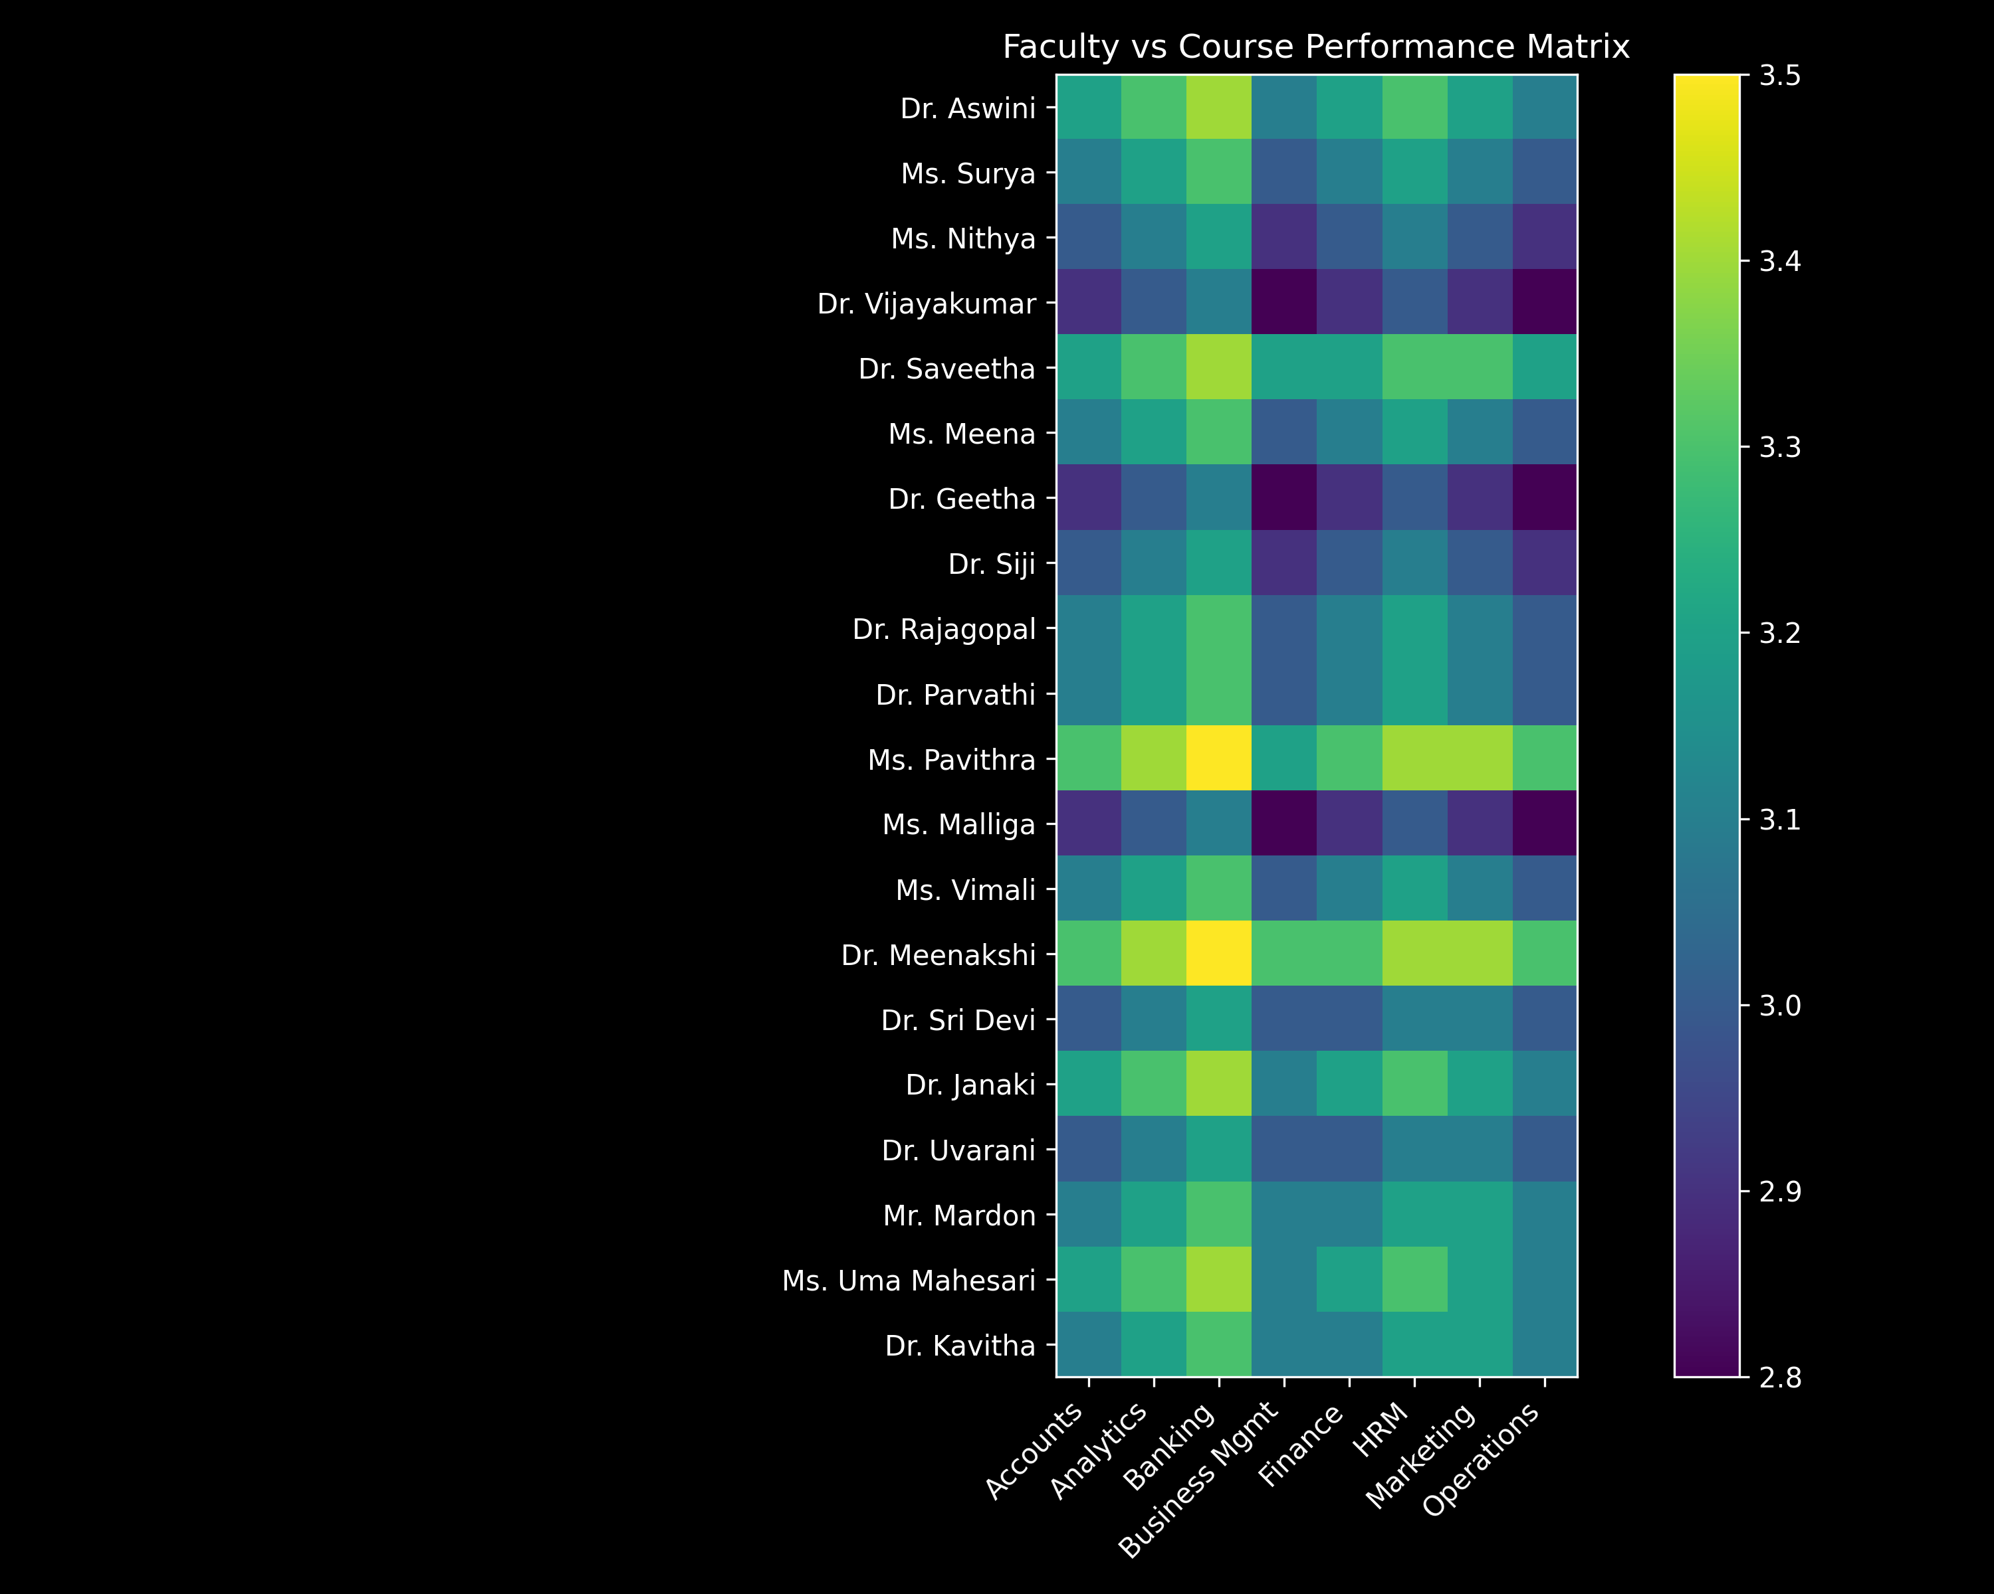

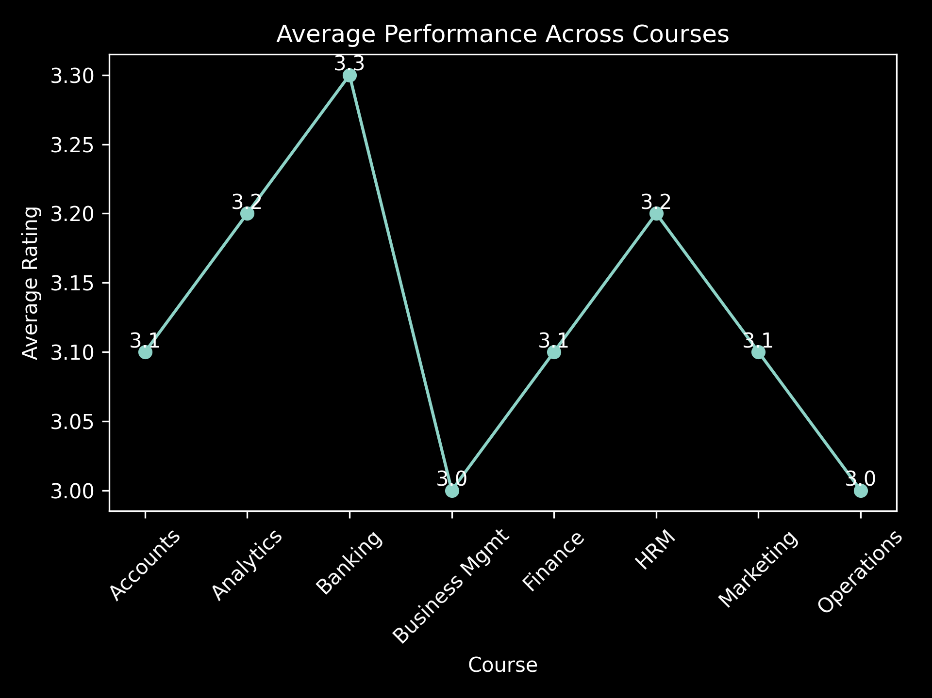

Interpretation

The faculty–course matrix shows that teaching performance varies across subjects, indicating faculty-specific strengths in certain courses. Courses like Banking and HRM receive higher ratings, while Business Management and Operations show relatively lower performance. This suggests the need to align faculty expertise with appropriate courses to improve overall student satisfaction.

Table: Tester-wise Analysis

Tester Category | No. of Responses | Total Score | Average Rating | Rank
Internal Testers | 260 | 801.3 | 3.08 | 2
External Testers | 240 | 749.4 | 3.12 | 1
Total | 500 | 1550.7 | 3.10 | N/A

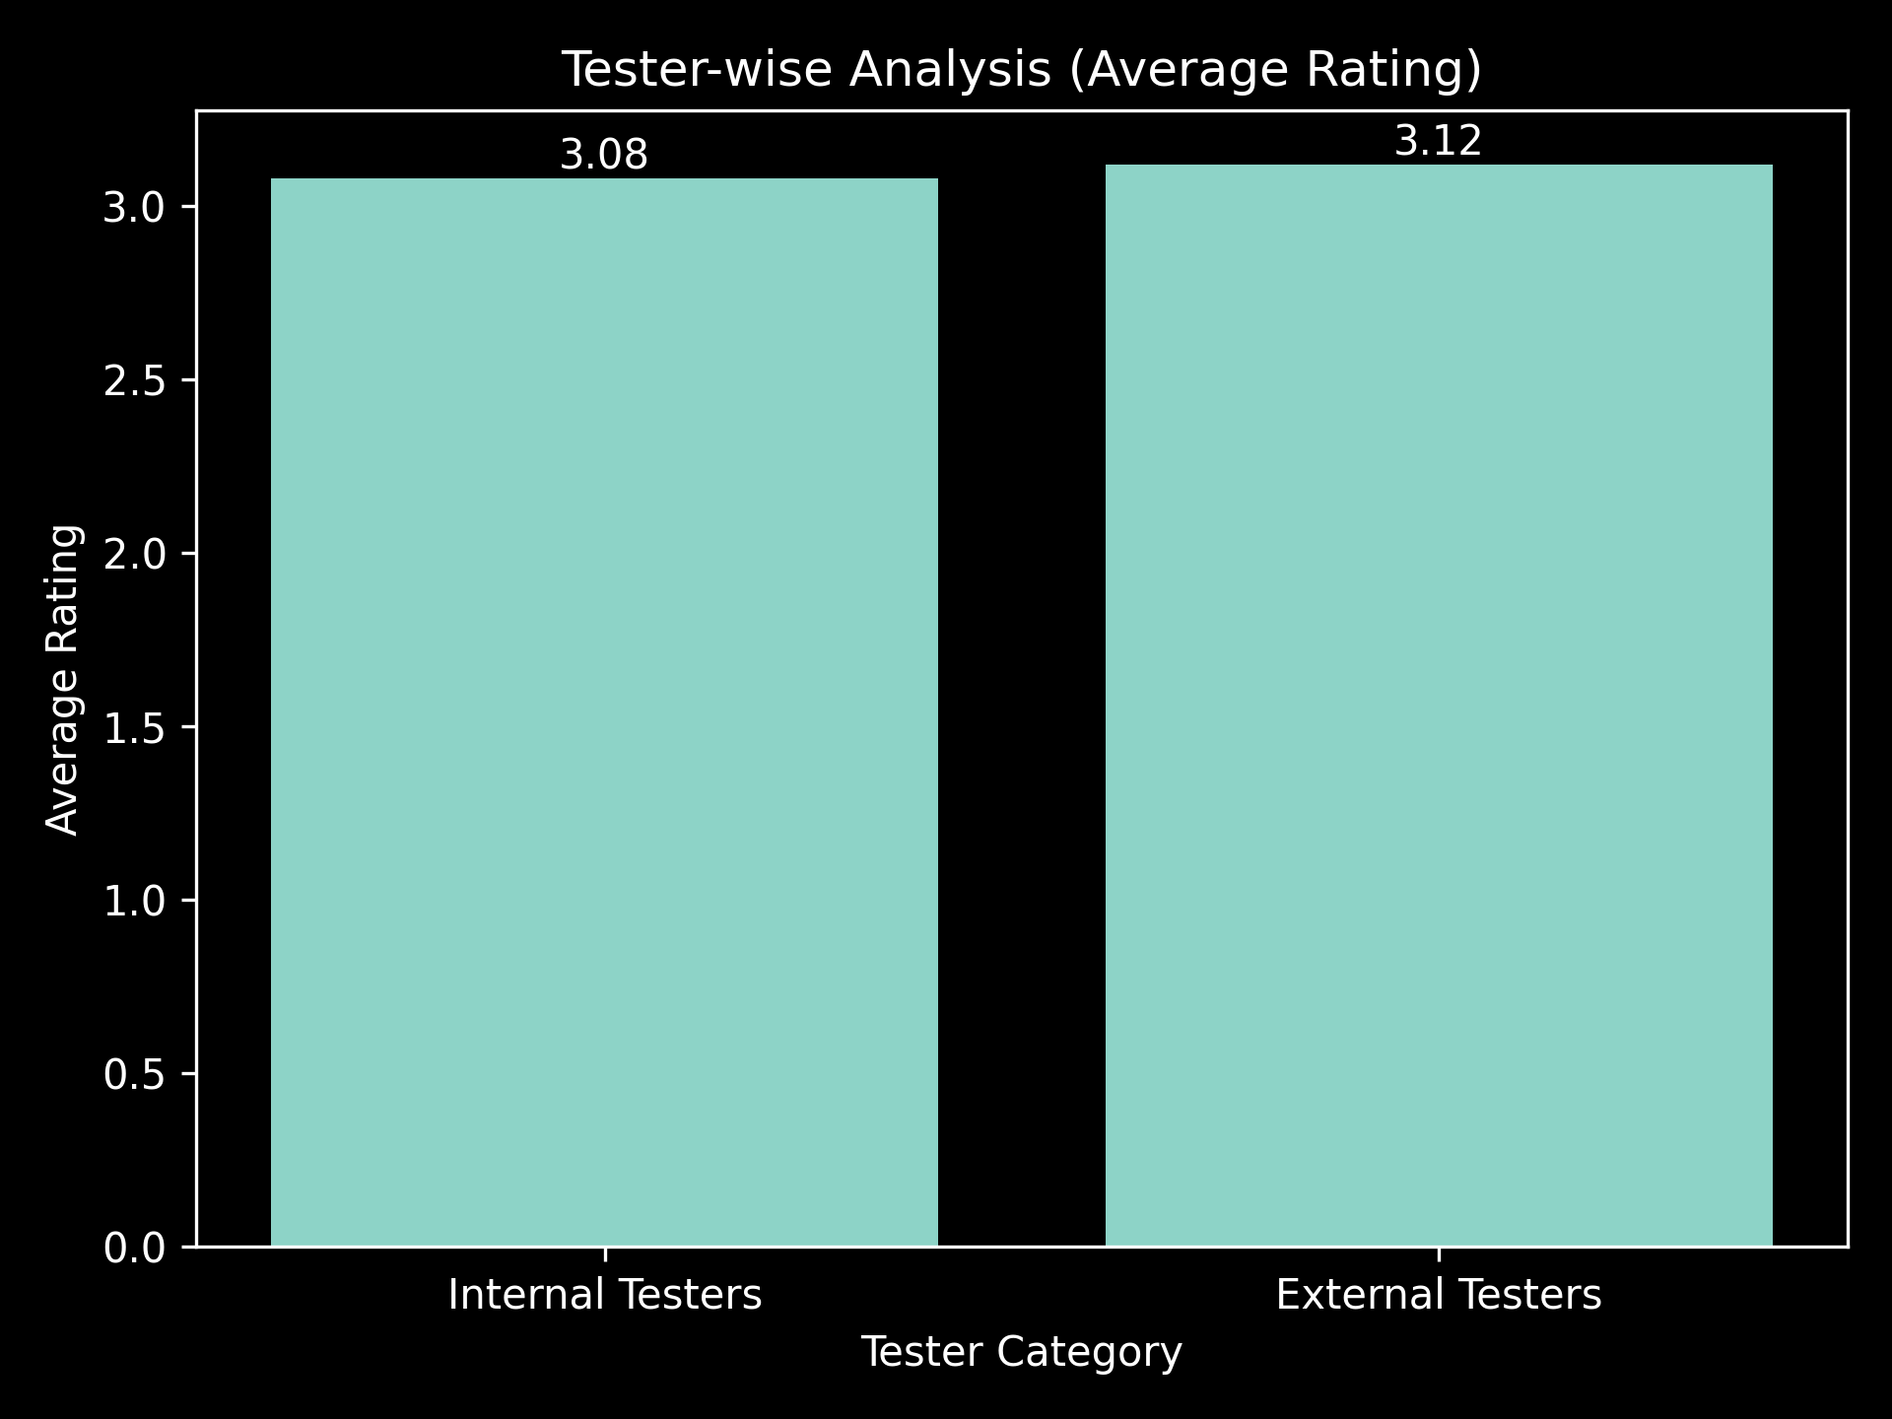

Interpretation

The tester-wise analysis indicates that external testers provide slightly higher ratings (3.12) compared to internal testers (3.08). This suggests a marginally more favorable perception from external evaluators, while internal feedback remains consistent. The variation is minimal, indicating overall stability and reliability in evaluation across both groups

Table: Question-wise Analysis

Question No. | Average Rating | Rank
Q19 | 3.21 | 1
Q8 | 3.20 | 2
Q6 | 3.18 | 3
Q11 | 3.16 | 4
Q2 | 3.15 | 5
Q9 | 3.14 | 6
Q16 | 3.13 | 7
Q3 | 3.12 | 8
Q13 | 3.11 | 9
Q5 | 3.10 | 10
Q10 | 3.09 | 11
Q1 | 3.08 | 12
Q7 | 3.07 | 13
Q12 | 3.06 | 14
Q4 | 3.05 | 15
Q14 | 3.04 | 16
Q18 | 3.03 | 17
Q15 | 3.02 | 18
Q17 | 3.01 | 19

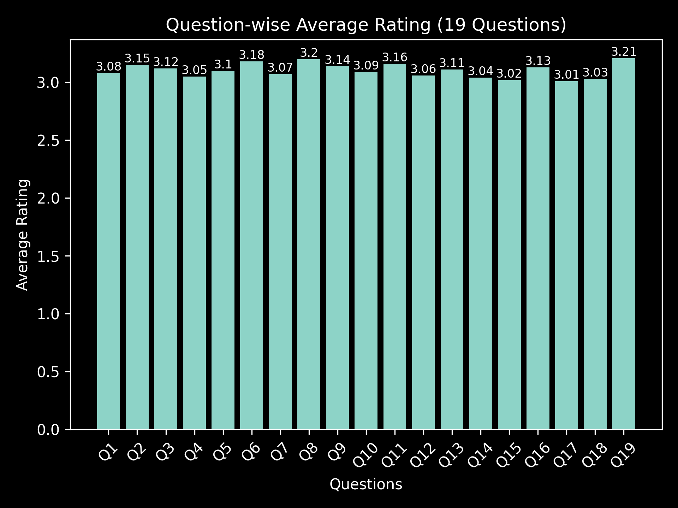

Interpretation

The question-wise analysis reveals moderate variation in student feedback across different teaching parameters. Certain aspects, particularly Q19, Q8, and Q6, receive higher ratings, indicating strong performance in those areas. In contrast, lower ratings observed in Q17, Q15, and Q18 highlight areas requiring improvement, especially in enhancing clarity, engagement, and instructional effectiveness. Overall, the results suggest consistent performance across most parameters, with scope for targeted improvements to enhance overall teaching quality and student satisfaction.

Problem Statement
- Educational institutions collect large volumes of student feedback to evaluate teaching effectiveness and course quality.
- In this study, 500 responses were collected, covering faculty, courses, departments, and semesters.
- However, this data is often underutilized due to lack of structured analysis and proper analytical tools.
- While numerical ratings are easy to summarize, textual feedback is difficult and time-consuming to analyze manually.
- There is also a lack of integration with AI techniques, making it hard to identify patterns and trends.
- As a result, important insights related to performance, student satisfaction, and improvement areas are often missed.
- Therefore, there is a need for a data-driven and AI-enabled system to analyze feedback effectively and support better decision-making.
Expected Outcomes

- The analysis of 500 student feedback responses will produce a clean and structured dataset for academic evaluation.

- Development of interactive Pivot Tables and dashboards to visualize:
- Faculty-wise performance
- Course-wise analysis
- Department-wise comparison
- Semester-wise trends

- Identification of top-performing faculty and courses along with low-performing areas requiring improvement.
- Generation of data-driven insights to support academic planning and decision-making.
- Implementation of basic sentiment analysis to interpret student comments effectively.
- Use of AI-based summarization to extract key themes and recurring issues from feedback.
- Improved teaching quality, student satisfaction, and institutional performance through actionable insights.
- Creation of a reusable analytical framework that can be applied across different courses, departments, and semesters.
- Improved data-driven decision-making for academic planning and performance enhancement.
- Ability to track trends and patterns using the 500-response dataset for continuous improvement.

- A complete project deliverable including:
- Structured dataset (500 responses)
- Interactive dashboards (Pivot Tables / Power BI)
- AI-generated insights & sentiment analysis
- Documentation and project repository

- Overall enhancement in teaching effectiveness, student satisfaction, and institutional performance.

